Competition: Electronic Pumpkin Postcards

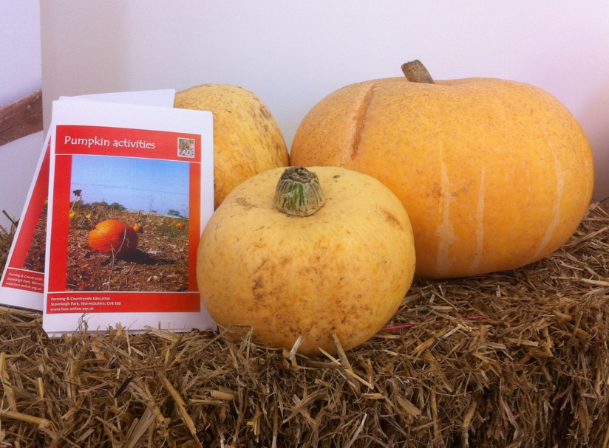
We would like to invite you to take part in this year’s pumpkin competition for Key Stage * pupils.

The competition is part of the ************* Pumpkin Festival at *********************,

The prize is a Day of Discovery across Art and Science for your whole class, whether the winning entry comes from an individual, a group or from the entire class.

Details

This year, we are asking you to use Science, I.T. and some artistic flair to create an electronic record of your pumpkin growing experience. We want your pupils’ work to be visible on our screens for visitors at the Pumpkin Festival.

Turn over to find out more about the competition.

website / social media / logo

Competition FAQ

What do we do?

- Collect your free pumpkin seeds from ********* this Spring (or use your own, if you prefer).
- Sow the seeds and grow the pumpkin plants.
- Record the process.

What should we record?

Its up to you! You might want to note times (e.g. for the seedlings to emerge from the soil), make comparisons, take measurements, photographs, videos or drawings. Use the NC Working Scientifically criteria to give you ideas.

How does this fit in with our science curriculum?

A good entry will probably include material from Working Scientifically, Reproduction in Plants and perhaps even Variation. We want to see good science skills as well as creativity.

How should the entries be presented?

This year all entries are to be submitted electronically, but beyond that, the choice of format is up to you.

Will your class submit:
a Vlog?
a PowerPoint?
An animation?
Or something else?

When is the deadline?

We need your entries by **************. When you are ready, email *************** to arrange the method of submission (this may vary according to the format of your entry).

Any other questions?

Email ****************** if you have any questions about the competition.

