 | Pig | Sheep | Goat | Chicken | Cow
 | 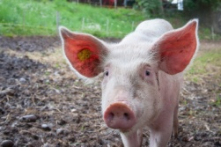 | 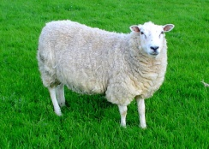 | 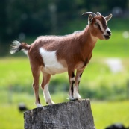 | 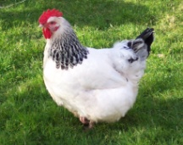 | 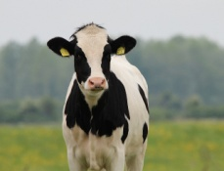
What is a male called? | Boar | Ram or Tup | Billy or Buck | Rooster or Cockerel | Bull
What is a female called? | Sow | Ewe | Nanny or Doe | Hen | Cow  (or heifer if she hasn’t given birth before)
What is an offspring (baby) called? | Piglet | Lamb | Kid | Chick | Calf
How long is the female pregnant for? | 3 months & 3 weeks & 3 days | 5 months | 5 months | Eggs hatch 21 days after they have been laid by the hen | 9 months
How many offspring can the female have each time she gives birth? | 10 – 12 piglets | 1 – 3 lambs | 1 – 3 kids | 1 chick per fertilised egg | 1 or 2 calves
How many times a year does the female give birth? | 2 times per year | Once a year in Spring | Once a year in Spring | Hens usually lay 5 eggs per week (260 each year).  8 out of 10 eggs will be fertilised if the hen lives with a cockerel | Once a year
What products do we get from the animal? | Meat | Meat, wool, milk | Meat and milk | Eggs and meat | Meat and milk
 | Pig | Sheep | Goat | Chicken | Cow
What is a male called?

What is a female called?

What is an offspring (baby) called?

How long is the female pregnant for?

How many offspring can the female have each time she gives birth?

How many times a year does the female give birth?

What products do we get from the animal?

