Ladies in Pigs

“Isolation Workbook – setting up a café”
For years 7-9
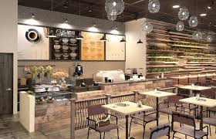
Introduction
Ladies in Pigs is a non-profit company which goes all over the country promoting and educating about the work that British Red Tractor farmers do to produce food to the highest standards.
We thought it would be a good idea, while we cannot visit schools in person, to create a workbook that you can complete and submit to us. We have several ex teachers on our staff who would love to see the work you do and give you some feedback.
Our workbook is based on an idea that Ladies in Pigs are opening a café to support the farmers. In the pages that follow, there are several tasks that you can complete and upload to our email or social media pages. All our contact and submission details are on the back page.
Red Tractor is a scheme that ensures that any food produced by a farmer in Britain under the scheme, has been done so to the highest welfare standards. You can find more about Red Tractor at www.redtractor.org.uk or on our website www.ladiesinpigs.co.uk.

So, let’s get started! On the next few pages are several tasks that we would love you to complete. These show your skills at all different subjects.
Have fun and let us see your work!

Task 1
We would like you to design the sign that will be outside of the café. The name of the café is Rosie’s Kitchen, in honour of our mobile kitchen that we currently bring to schools. We lovingly call it Rosie. (see pic below).
- You need to think about colours, fonts, wording, design and other features.
- You can either use your computer and use Draw, Publisher or other programs, or you can draw it yourself and take a photo of your design to send it in.
- You need to think of a suitable scale to use so that your drawing is to the correct scale. The full-size dimensions of the sign would be 60cm x 720cm.
Extension
Use the internet to research about shop signs and what they can be made of. Write down what material you would choose and why on your design.

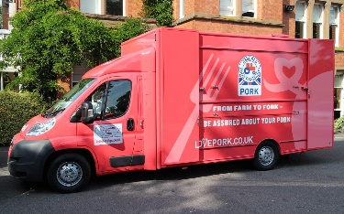

Task 2
Now we have the sign created, we are moving inside the café. The next part is to think about how many customers we can have seated at the tables.
- Use the graph paper in the link below to draw the café seating area to scale. Remember to show what your scale is outside of the drawing.
- Draw the seating area to scale and then draw in the number of tables and chairs that you can fit in the space. REMEMBER: you need to allow a minimum of 45cm between each table to allow for people to get in and out.
- Remember to label everything on your plan and have fun choosing the design of tables and chairs you want.
- When you have finished your 2D plan of the café, either video, voice record, or write your justification for the table design you chose and stating the number of customers who could sit down when the café is full.
Hints
- Here is a link to a company website which has tables and chairs, or you can use your own source. www.nisbits.co.uk
- Here is your link to the graph paper E:\shows 2020\educational resources\ks3-4\graph blank grid.png
- The dimensions of the café seating area are 6m x 9m with a door at the front that is 1m wide in the centre of the front of the café.
Extension
Using the catering website, work out how much it would cost to buy the tables and chairs you have planned for.

Task 3
When cooking and serving food, there are lots of different rules that you need to consider to keep customers safe from bacteria.
Have a look at the poster near the back of this workbook which gives you all the information about temperatures etc to keep food and customers safe.
When you have looked at the poster, answer the questions below:
- What temperature does a refrigerator need to be below to keep food safe?
- If you want to reheat a dish to serve, what temperature MUST it reach to kill off bacteria?
- What temperatures are in the danger zone?
- How many degrees difference is the danger zone?
Extension
Using a dictionary, computer-based thesaurus or the internet, find out the meaning of the following terms and write them down.
Cross contamination
Bacteria
EHO

Task 4
Here’s a practical task to show what you have learnt in Task 3.
Get a piece of bread and put it in a see-through plastic bag or wrap it in clingfilm – maybe choose the crust that most people don’t eat! Place it on the windowsill in your kitchen. Using the table below, record what changes with the bread over the next week. REMEMBER: what makes a fair experiment?
Day | Time | Physical changes
1

2

3

4

5

6

7

Conclusion
Write a few sentences to describe what has happened over the week.
……………………………………………………………………………………………………………………
……………………………………………………………………………………………………………………
……………………………………………………………………………………………………………………
……………………………………………………………………………………………………………………
Task 5
This task is back to being creative!
We would like you to design an invite to a “Taster Night” at the café to introduce newspaper reporters and food critics to the new venture.
We need you to design a suitable invite that would get reporters and food critics to come and take part in the evening. (This can be a hand drawn creation or handwritten).
- Think about the type of writing you need e.g. persuasive
- What details need to be included?
- Would your invite be electronic or printable to post to them? How would you get replies to know how many of the tasters to cook?
- Think about the dates you put on, allowing enough time for a reply e.g. if the event was on 25th May, you may ask for replies by 18th May.
- Would you include images on you invite?

Task 6
For task 6, we would like you to take some time to reflect on and research the words associated with the work we do here at Ladies in Pigs.
Using our website – www.ladiesinpigs.co.uk; google etc, find different words that relate to British Red Tractor, farming and Ladies in Pigs.
Then using a website like; www.wordclouds.com, make a wordle which shows all of the words you have found. On this website, you can be very creative with the shape, colour etc – so let your creative side out and enjoy!
We would love to see the different words and your design.
Remember to save your wordle and either submit it with all your tasks in one go or send via email to us.

Task 7
You have received the replies to your invite to the Taster Night.
You have decided to make the dishes in the 2020 recipe booklet for the evening and need the portion numbers below. The recipe booklet can be found at https://www.ladiesinpigs.co.uk/uploads/2/7/3/0/27303819/ladies_in_pigs-_recipe_book_16pp.pdf
As a team, you have decided to choose 2 recipes each to prepare for the evening to share the workload.
Choose your 2 recipes from the list below, and then work out how much of each ingredient you need to make it. Write the new recipe down with the correct amounts of ingredients on it.
The list below shows the quantities needed for the event.
Porchetta - 60 portions
Flapjack - 120 portions
Tartiflette - 48 portions
Stirfry - 60 portions
Jerk belly - 80 portions
Meatballs - 72 portions
Bacon salad - 120 portions
Aromatic pork - 120 portions
Sausages - 100 portions of each flavour

Extension
Describe how you worked out correct amounts for the 2 dishes chosen. Show a check of how you worked it out.
Task 8
Imagine you are one of the reporters that has been to the taster night at Rosie’s.
Write an article for your newspaper, detailing what happened and what you thought about the café and the food.
- Remember what format a newspaper article needs to be in.
- What other features could be added to your article to make it appeal to the reader?
- What tense will your writing be in?
- You can produce your article either handwritten or using a computer.

Task 9
Any business needs technology to run well. We need you to think of all the technology that might be needed for the café.
Remember, you can use Google, or the Nisbits website from earlier who supply to food businesses e.g. cash registers, thermometers etc.
Fill in the table below show what you have researched.
Item | Use within the business | Price

Extension
Pick 3 essential items and use a price comparison website such as www.pricerunner.co.uk to get the best price possible. Record your findings below.
Item | Price | Where from

Food hygiene resource
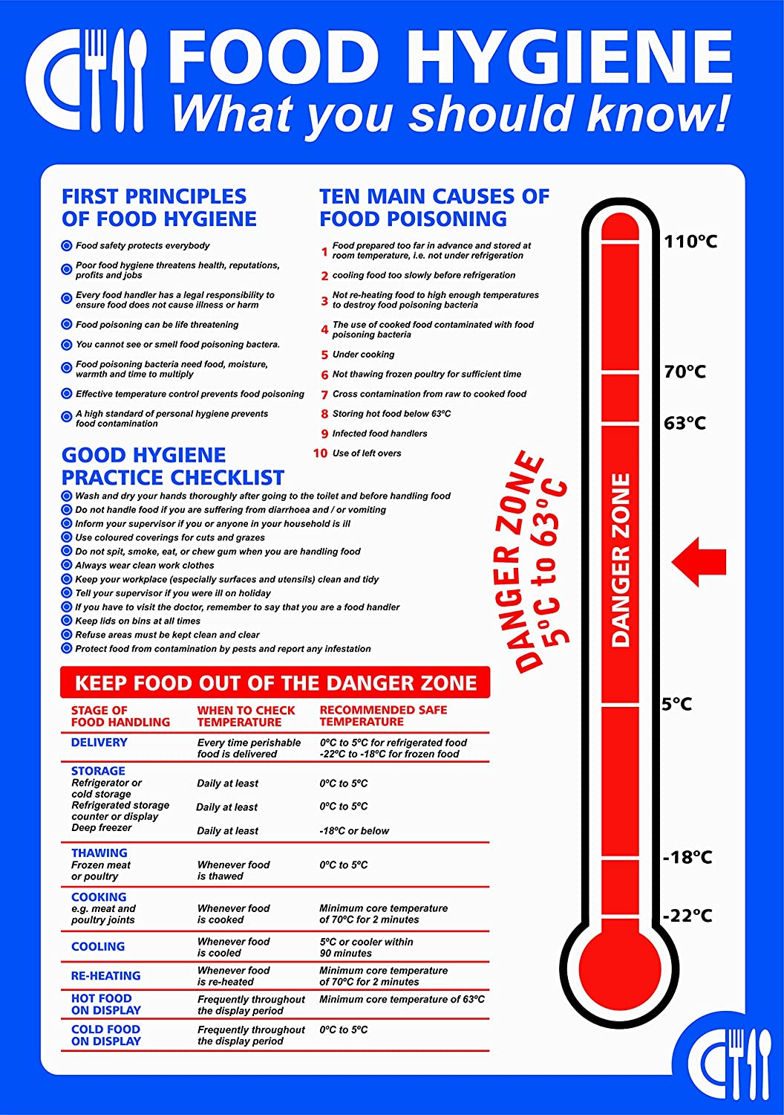

Submission notes
To submit your work, you can send it to the address below if you prefer to print off and work on paper – or you can simply save your work and email it to us.
Please ensure your first name, age and contact details are included, as we would love to give you feedback on your work.
When you submit your work, please state clearly if you DO NOT wish for your work to be shared on social media or our website. We would only state your first name and age on any work shared. You can refuse permission by writing this sentence on your submission.
Please do not share any of my work on social media platforms.
We hope you enjoy this project and can’t wait to see your work.

Ladies in Pigs
Southfield Farm
East End Road
Preston
HULL
HU12 8SJ
Email: ladiesinpigs@gmail.com

