**Farm Animals - Similarities and Differences.**

**Which of these are farm animals? Draw a circle round the farm animals.**

Lion Chicken Lamb Zebra

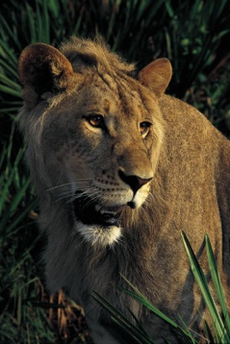 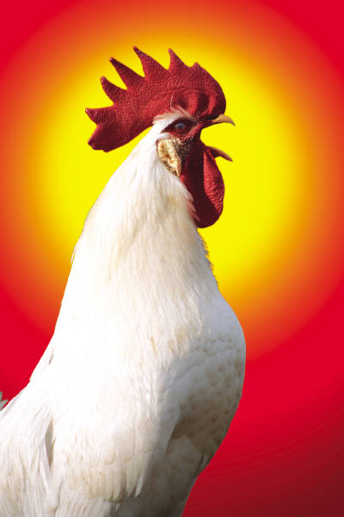 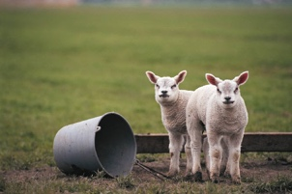 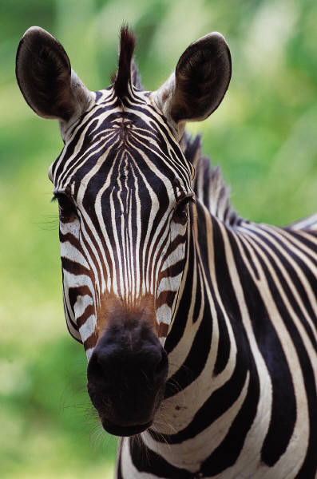

**How many farm animals can you think of? Write them in the box.**

**Look at these farm animals. Can you say how they are different? Can you say what is the same about the animals?**

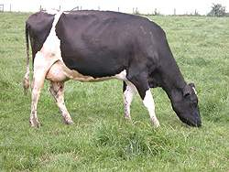 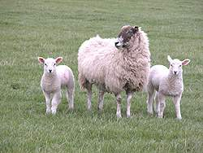

|  |  |
| --- | --- |
| **Same** | **Different** |

**Match the babies and adults.**

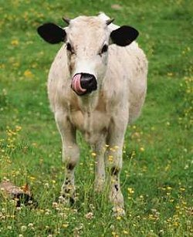 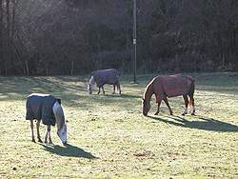

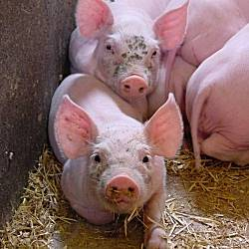 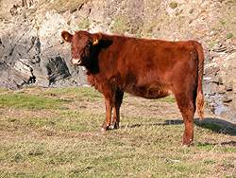

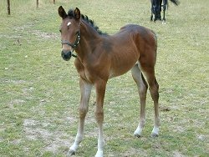 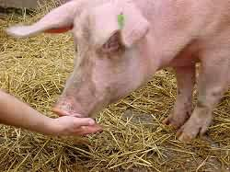

|  |
| --- |
| **How are the babies and the adults different?** |