How to grow mushrooms….

What is a mushroom farm?
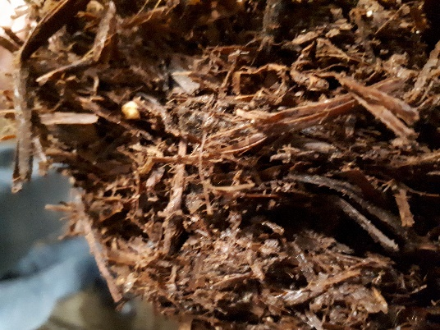
Designed and built in the 1980s the Leckford mushroom farm uses a shelving system known as the bulk system. Mushroom compost is delivered twice a week and laid onto 22 metre long shelves that completely fill a room from floor to ceiling. The farm has sixteen specially designed large (bulk) growing rooms, with a new room being used for each delivery of compost. The process of growing mushrooms takes six weeks and each room within the farm is at a different stage. The shelves do not move at all, the conditions in the rooms change as the needs of the mushroom crop change.
Only brown chestnut mushrooms are grown at the Leckford mushroom farm, as it is the most popular amongst the Waitrose customers. Also known as the Agaras Pious Porous – heirloom mushroom, and developed 15 years ago it is easier to grow than traditional varieties and has revolutionised the brown mushroom growing industry.
What is mushroom compost?
Mushroom compost (substrate) consists of wheat straw (containing mycelium), gypsum, oat straw and chicken litter. Prior to being delivered to the mushroom farm, the compost has been aired to encourage natural bacteria to grow and been pasteurised to get rid of harmful pathogens and bacteria. It is possible to see the mycelium (mushroom spores) which are attached to the straw within the mushroom compost.
How to grow mushrooms?
Each growing room houses shelves which contain a layer of mushroom compost, with a casing layer of peat on top, in order to create the correct microclimate for the mushrooms to grow. The casing layer acts as a reservoir to retain water as the mushrooms need a damp environment to grow. The peat has been treated to achieve 6.6PH as the mycelium prefers to grow in that environment.
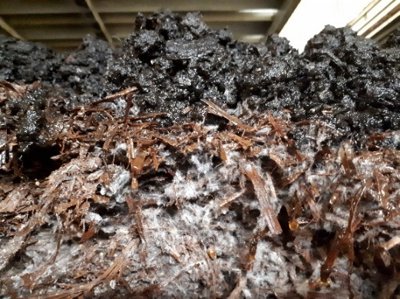
The thickness of the peat is important, too thin and the crop is limited, too thick and the mycelium is too hot to develop, so will need to be cooled. The ideal temperature for the mycelium to grow is between 25-30 C.
Within each of the rooms at the mushroom farm, the temperature and humidity of the air, the compost and the peat are managed to recreate autumn and maximise the mushroom yield.

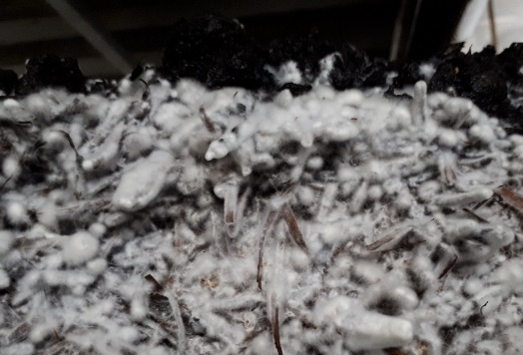
Up to 18 litres of water per square metre are added to each shelf to keep the peat damp enough for the mycelium to grow.
By Day 4, it is possible to see the mushroom mycelium as the spores work their way through the casing layer.
The farm workers now ‘fluff up’ the layer of peat to increase the surface area, and the potential growing area of each shelf.
Creating a damp environment, with perfect conditions for the mushrooms to grow encourages the mycelium to grow naturally.
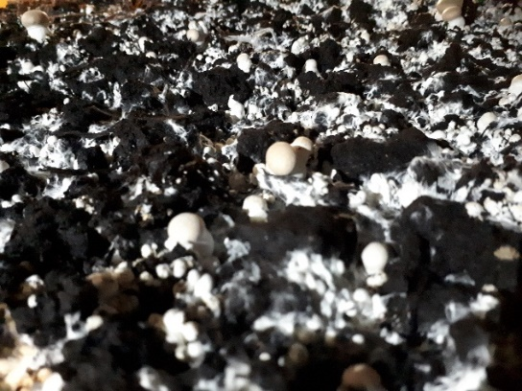
By day 7, the mushroom mycelium has developed on the surface of the peat. Until now the growing rooms were kept airtight to reduce the level of oxygen and trap the CO₂ to help the mycelium believe that it is really growing naturally in the autumn on a woodland floor, amongst dead leaves.
Now the room is ‘vented’, and fresh oxygen comes in through vents. The mycelium believes it is above ground and begins to develop into a living organism, a fruit body which can be treated as a food product.
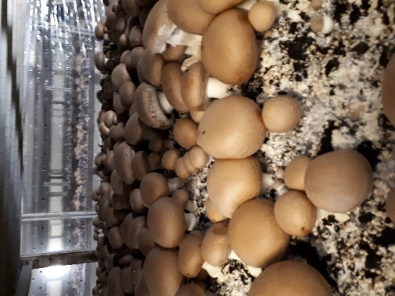
When the fruit bodies begin to appear the air temperature in the growing room is dropped to slow mushroom growth so not all of the mushrooms are ready to be picked at the same time.
On day 16, the harvesting team will begin to harvest the mushrooms. They are still small enough to be classed as cup mushrooms. The crop will be carefully thinned to ensure that there is enough room to enable some mushrooms to continue growing.
By day 23 the larger mushrooms are ready to be picked (now known as portobello mushrooms). Whilst the cooler temperature of the growing room will also have encouraged another flush of cup mushrooms to be growing alongside them.
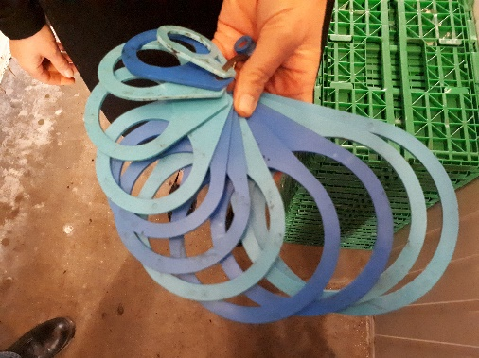
The picking team use a set of measures to ensure that, through careful picking, they are able to maximise the yield of each growing room. They will visit each shelf once a day to decide at what stage of growth each mushroom should be harvested.
Each supermarket sets their own ‘standard sizes’ for the different types of mushroom they sell. The Waitrose Store expects that cup mushrooms will be between 30-60mm in diameter and that portabella mushrooms will be up to 150mm

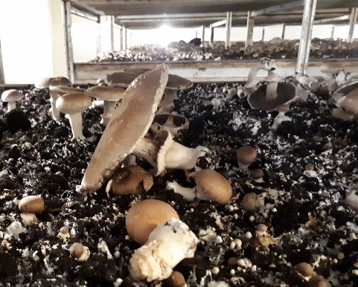
Once picking has started, the environment in the growing room becomes warm and damp to encourage another flush of mushroom growth. Mushrooms that haven’t been picked in time remain on the peat bed turning black, whilst younger mushrooms grow alongside them. Careful management of the environment within the growing room makes it possible for the compost to support several flushes/crops of mushrooms.
Once the compost is ‘spent’ it is removed by a specialist company to be pasteurised so that no pathogens created during the mushroom growing process remain. The ‘clean’ compost is then recycled, often added to arable fields on the Leckford Farm or sent to a compost company to be treated and then sold at the Leckford Farm Shop as mushroom compost, for customers to use in their garden.
What happens to the mushrooms after they have been picked?
The picking team use a very sharp knife to carefully harvest each. It can take up to 6 months for a mushroom picker to be cleared to work without close supervision as their decisions have a direct impact upon the quality and quantity of a growing room’s yield.
Each mushroom is touched only once prior to being transported straight to the packing room. There it will be graded according to its size:
- Closed Cup Mushroom – Over 66% of the Leckford mushrooms are sold in this way, packaged in a punnet and distributed to Waitrose stores nationwide
- Porta Bellini Mushroom – approximately 9% of Leckford mushrooms are sold as the ‘Small English Breakfast mushroom’ packaged within a punnet and sold in stores nationwide.
- Portobello Mushroom – 22% of Leckford mushrooms are sold in a punnet in Waitrose stores nationwide or left loose for customers to choose and place in a paper bag
- Portobello as a Regional Mushroom – Only 2% of the Leckford mushrooms are packaged in this way to be sold in punnets across Waitrose stores within the South of England
- Brown Chestnut Mushrooms- whilst under 1% of the mushrooms (including some that do not meet the rigorous high standards of the Waitrose stores) are sold loose in the Leckford farm shop, as well as being used within the farm shop café kitchen.

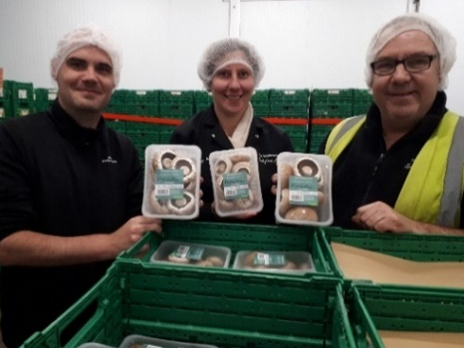
The Pack house team are also responsible for labelling the mushrooms and ensuring they remain fresh by quickly placing the punnets within a chilled environment. Once sorted and packaged they are taken directly to a Waitrose distribution centre before being transported to store and placed on a shelf. Mushrooms can be placed in a customer’s trolley within 36 hours of being picked at the Leckford Mushroom Farm.
The British Retail Consortium Audits take place in the pack house to ensure that the mushrooms are safe for consumption.

