Secondary Science;
Farm based activity ideas
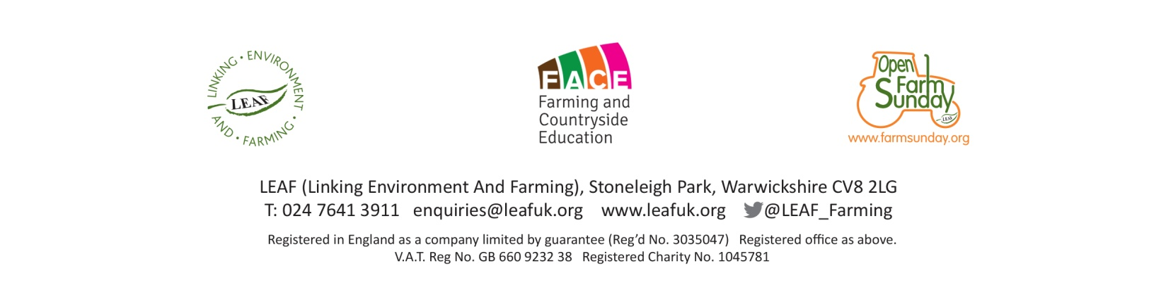
Stock Judging
Curriculum Links  GCSE Science | - Describe that the genome and it’s interaction with the environment influence the development of the phenotype of an organism (OCR)  - State that there is usually extensive genetic variation within a population of a species (OCR)  - Explain the impact of selective breeding on animals (OCR, Pearson Edexcel & AQA)  - Investigate inheritance using suitable organisms (Pearson Edexcel)  - Evaluate the benefits and risks of selective breeding in modern agriculture (Pearson Edexcel)
Aims | - To understand that farm animals are selected for breeding depending on their characteristics (traits)  - To understand which traits are selected and why they are selected in various farm animals  - To understand traits are inherited, but environmental factors (such as nutrition, management) can affect (mask) the heritability of a trait  - To be able to discuss the impact, benefits and risks of selective breeding in farm animals
Resources | - Stock; have several animals available displaying various trait examples for the particular species and within the breed. Animals used must be quiet and used to being handled.  - Pens / area to easily observe / handle stock  - Breed catalogues  - Historical pictures / photographs of stock showing how they have changed over time  - Stock judging guide ie showing desirable traits. https://beefandlamb.ahdb.org.uk/wp-content/uploads/2015/12/BRP-stockjudging-guide-2015.pdf  - Some breed society websites have information relating to breed standards
Demonstration | Using a good example of an animal for the breed, talk through what you as a Stockperson look for – ie the desirable traits. Explain why these traits are desirable. If you have them in your herd or flock, show a poor example for the breed and explain why you would not select this animal for breeding. If you have other breeds of the animal, compare the characteristics of the two breeds ie Jacob and Suffolk sheep. Talk about how the way in which an animal is managed can mask a trait. If you have the information / pictures available, show how your herd / flock has changed overtime. Talk about what has driven this change and if you have seen any benefits or problems with these changes.
Activity | Depending on the number of students and farm staff available, will depend on how this session is organised. If there are low student numbers and enough farm staff it may be that 2 or 3 students could work with a member of farm staff to assess an animal. If not, it may be that 1 or 2 students volunteer to assess an animal, with the help of farm staff, in front of the rest of the group. Throughout the assessment encourage students to look for the desirable traits and explain why they are desirable.

