Secondary Science;
Farm based activity ideas
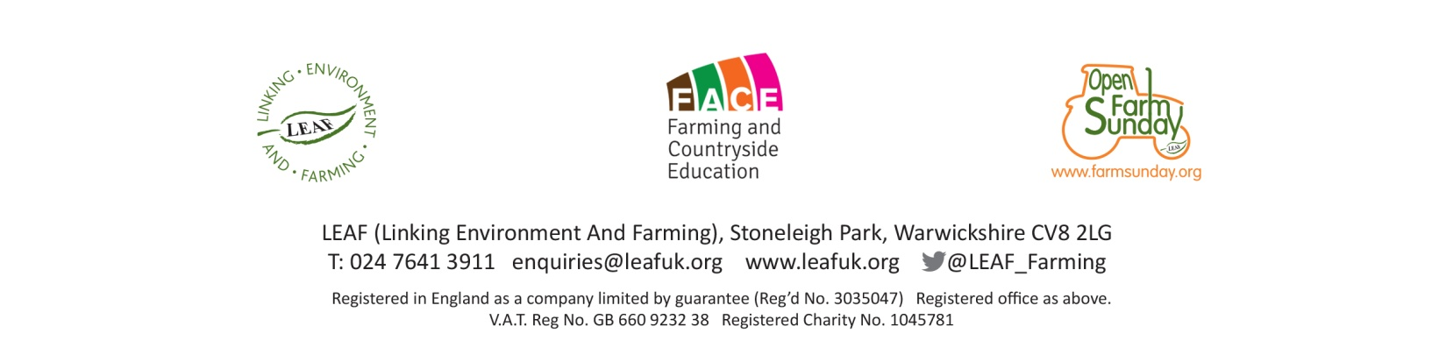
Introduction to Selective breeding
Curriculum Links  GCSE Science | - Describe that the genome and it’s interaction with the environment influence the development of the phenotype of an organism (OCR)  - State that there is usually extensive genetic variation within a population of a species (OCR)  - Explain the impact of selective breeding on animals (OCR, Pearson Edexcel & AQA)  - Investigate inheritance using suitable organisms (Pearson Edexcel)  - Evaluate the benefits and risks of selective breeding in modern agriculture (Pearson Edexcel)
Aims | - To understand that farm animals are selected for breeding depending on their characteristics (traits)  - To understand which traits are selected and why they are selected in various farm animals  - To understand traits are inherited but environmental factors (such as nutrition, management) can affect (mask) the heritability of a trait  - To be able to discuss the impact, benefits and risks of selective breeding in farm animals
Resources | - Stock; have several animals available displaying various trait examples for the particular species and within the breed. Animals used must be quiet and used to being handled.  - Pens / area to easily observe / handle stock  - Breed catalogues  - High street catalogues with a wide range of a particular product  - Historical pictures / photographs of stock showing how they have changed over time
Activity | Split group in to 2’s / 3’s and using the high street catalogues ask the groups to select a product eg a television, from the range in the catalogue. Each group must be able to justify why they have chosen that particular item compared to others in the range (reasons may be price, availability, size, performance, colour etc). Discuss with the whole group how they chose their items, what was their reasoning, were there any similar reasons between groups? Discuss the idea that the pupils made their choices based on the characteristics of the product.  Show the group some breed catalogues and explain that farmers go through the same process when selecting which animals to breed from. Farmers select animals on the basis of characteristics ie traits.  With the farmers help, can the group come up with a list of traits farmers would be looking for in a dairy cow, beef cow or breeding ewe?  Using your farm stock show examples of animals you currently breed from and why you have chosen these particular animals. If you have them in your herd / flock show a poor example and discuss why you won’t breed for that particular animal.  If you have old photographs of stock you can show how animals have changed over time. You can discuss what has driven this change and talk about any benefits or problems associated with these changes.

