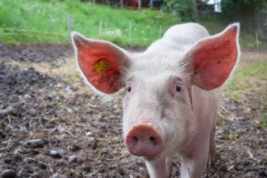
A male pig is called a...... | A female pig is called a...... | A baby pig is called a...... | A female pig is pregnant for......
Boar | Sow | Piglet | 3 months & 3 weeks & 3 days
A female pig can have...... | A female pig gives birth...... | What products do we get from pigs?
10 – 12 piglets each time she gives birth | 2 times each year | Meat

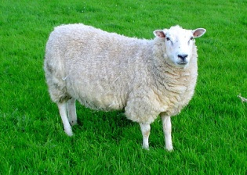
A male sheep is called a...... | A female sheep is called a...... | A baby sheep is called a...... | A female sheep is pregnant for......
Ram or Tup | Ewe | Lamb | 5 months
A female sheep can have...... | A female sheep gives birth...... | What products do we get from sheep?
1 – 3 lambs each time she gives birth | Once a year in Spring | Meat, wool, milk

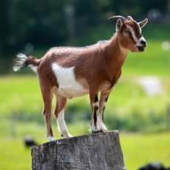
A male goat is called a...... | A female goat is called a...... | A baby goat is called a...... | A female goat is pregnant for......
Billy or Buck | Nanny or Doe | Kid | 5 months
A female goat can have...... | A female goat gives birth...... | What products do we get from goat?
1 – 3 kids each time she gives birth | Once a year in Spring | Meat and milk

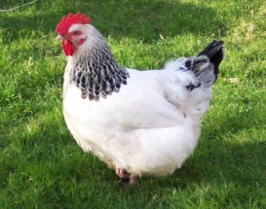
A male chicken is called a...... | A female chicken is called a...... | A baby chicken is called a...... | A female chicken sits on her eggs (incubates them) for......
Rooster or Cockerel | Hen | Chick | 21 days
A female chicken can have...... | A female chicken can lay...... | What products do we get from chickens?
1 chick per fertilised egg | 5 eggs per week (260 each year). 8 out of 10 eggs will be fertilised if the hen lives with a cockerel | Eggs and meat

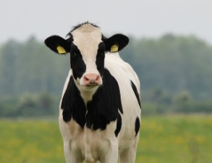
A male cow is called a...... | A female cow is called a...... | A baby cow is called a...... | A female cow is pregnant for......
Bull | Cow  (or heifer if she hasn’t had a calf before) | Calf | 9 months
A female cow can have...... | A female cow gives birth...... | What products do we get from cows?
1 or 2 calves each time she gives birth | Once a year | Milk from dairy cows  Meat from beef cows

