Make a Meal of It worksheets
Contents
The First Great Food Waste Weigh In
What food is being thrown away today?
Make a Meal of It Action Plan
Example of a letter home
Example of pupil survey for those having school meals
The Second Great Food Waste Weigh In
Activity 2: Where does our food come from? calculating the distance travelled
Activity 2: Where does our food come from? Blank and Food Top Trumps
Activity 4: What is food waste? Which items can go in the compost bin?
Activity 5: Why do we throw it away? Best before or still tasty after? Looking at the dates on food
Writing for a purpose… I can choose vocabulary to describe lunch time and what I am eating
Fascinating Foodie Fact File blank
The First Great Food Waste Weigh In
Date | What is on the menu today? | Infants  (weight of food waste in Kg) | Juniors  (weight of food waste in Kg) | Total  (weight of food waste in Kg)

Mean weight = Mode weight = Median weight =
What food is being thrown away today? Date:
Food description | Estimated percentage of the waste | Notes/ diagram

Make a Meal of It Action Plan

What is the problem? | What are we going to do? | Who is involved? | When are we going to do it? | Have we been successful?
Example of a letter home
Dear Parent/Guardian
Children in year/class …… have been learning about food and the impact wasting food has. Did you know that most households in the UK could save about £60 every month on food if they ate everything they purchased? In fact, the food we throw away each year requires 250,000 billion litres of water to grow it and could have made hundreds of meals if it had been eaten, rather than thrown away!
This week children at our school have been involved in a project that aims to reduce the amount of food waste produced at lunch time in our school. Over the course of the week …… Kg of food were thrown away by children in our school canteen. We are working with everyone in our school, including catering staff, and hope that this will be reduced over the next 4 weeks. If you would like to take on the challenge to reduce your food waste at home here are our three top tips,
•Plan meals for the week and only buy ingredients you know you will use.
•Check your fridge is set between 3-5 °C as this is the most effective temperature to keep food fresher for longer!
•Keep any leftovers in sealed containers in the fridge and check out recipes for these delicious morsels.
We look forward to reporting on any changes we have made over the course of the term.
Many thanks for your support,
Year ….. / Class …..

Example of pupil survey for those having school meals
We would like to know what you think about our school dinners. Please answer these questions to help us.

1. How often do you have a school dinner?
Every day Most Days Once a week Occasionally
2. What is your favourite meal at school?
____________________________________________________________________________________________
3. What is your favourite pudding at school?
____________________________________________________________________________________________
4. What foods do you not like at school?
____________________________________________________________________________________________
5. Do you think the portion sizes are:
Just right Too big Too small
6. How could the lunch time be improved at your school? (think about the food, plates, eating hall arrangements, time allowed to eat, noise levels in the dining hall etc)
____________________________________________________________________________________________ ____________________________________________________________________________________________
The Second Great Food Waste Weigh In
Date | What is on the menu today? | Infants  (weight of food waste in Kg) | Juniors  (weight of food waste in Kg) | Total  (weight of food waste in Kg)

Mean weight = Mode weight = Median weight =
Activity 2: Where does our food come from? - calculating the distance travelled

Product | Origin | Cost (£) | Distance travelled
Average distances the food has travelled:
Mean distance = Mode distance = Median distance =

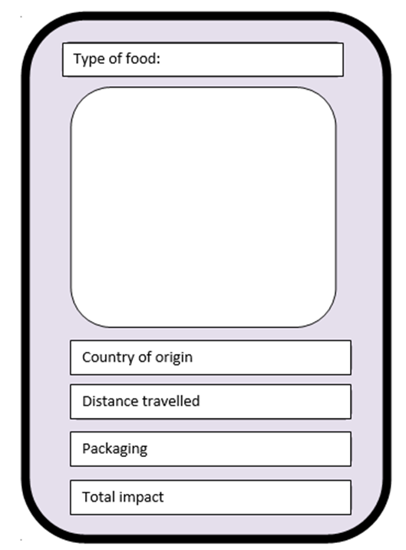

Egg shells | Juice carton
Fish bones | Dog food
Tea bags | Cling film wrapping
Fruit peel | Hair
Cheese | Dust from the vacuum cleaner
Bread | Used nappy
Cereal packet | Vegetable peelings
Egg box | Used kitchen towel
Empty can | Meat bones
Crisp packet | Nuts
Cooking oil | Yoghurt

Egg shells | Juice carton
Fish bones | Dog food
Tea bags | Cling film wrapping
Fruit peel | Hair
Cheese | Dust from the vacuum cleaner
Bread | Used nappy
Cereal packet | Vegetable peelings
Egg box | Used kitchen towel
Empty can | Meat bones
Crisp packet | Nuts
Cooking oil | Yoghurt

Egg shells | Juice carton
Fish bones | Dog food
Tea bags | Cling film wrapping
Fruit peel | Hair
Cheese | Dust from the vacuum cleaner
Bread | Used nappy
Cereal packet | Vegetable peelings
Egg box | Used kitchen towel
Empty can | Meat bones
Crisp packet | Nuts
Cooking oil | Yoghurt

Activity 5: Why do we throw it away? Best before or still tasty after? Looking at the dates on food.
Product | Best Before date on product | Today’s date | Look | Smell | Taste | Feel

Writing for a purpose… I can choose vocabulary to describe lunch time and what I am eating.
What can I feel?

What can I smell?

What can I hear?

Adjectives

Onomatopoeia

Nouns

Verbs

Adverbs

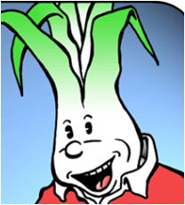
How many fascinating facts about food waste can you record – think about where you sourced this information and whether it is reliable?

