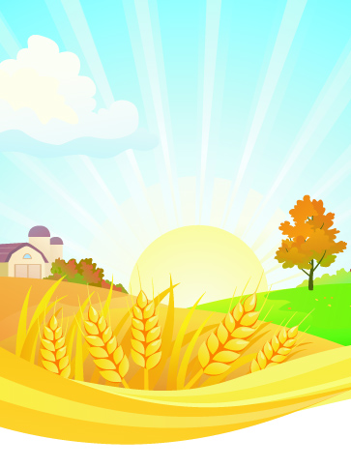

Information kindly provided by Bayer Crop Science UK

**1. 57% of all of the land in the UK is used for agriculture.**

**2. 5.4% of UK land is used to grow crops.**

**3. If the land used for crop protection was a perfect square, it would take you just over 22 days to walk the perimeter (without any breaks).**

**4. There are 280,000 farms in the UK and East Anglia is the top crop producing region.**

**5. East Anglia produces enough barley to make 2.5million pints of beer each year.**

**6. The UK produces 7.8million tonnes of wheat for bread making annually.**

**7. The average person buys 43 loaves of bread per year.**

**8. 5.5million tonnes of potatoes are produced in the UK each year – that’s enough to make around 27.5billion packets of crisps.**

**9. 60% of food eaten in the UK is grown in Britain.**

**10. 77% of shoppers agree it is important to support British farmers.**

**11. UK crops produced each year by value:**

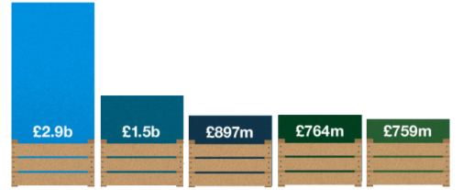

**Cereals Vegetables Potatoes Oilseed Rape Fruit**

**12. For every £1 invested in farm support, farming delivers £7.40 back to the economy.**

**13. The iconic British countryside, which farmers manage, generates over £21billion in tourism income each year.**

**14. The farming sector spends £13.5billion on goods and services each year.**

**15. The UK agri-tech sector contributes £14.3billion to the UK economy.**

**16. A large tractor can do in a day what used to take 100 people a week.**

**17. Did you know that if you put all the UK’s hedges together, they’d circle the earth 20 times.**

**Future Farming Fact Sheet**