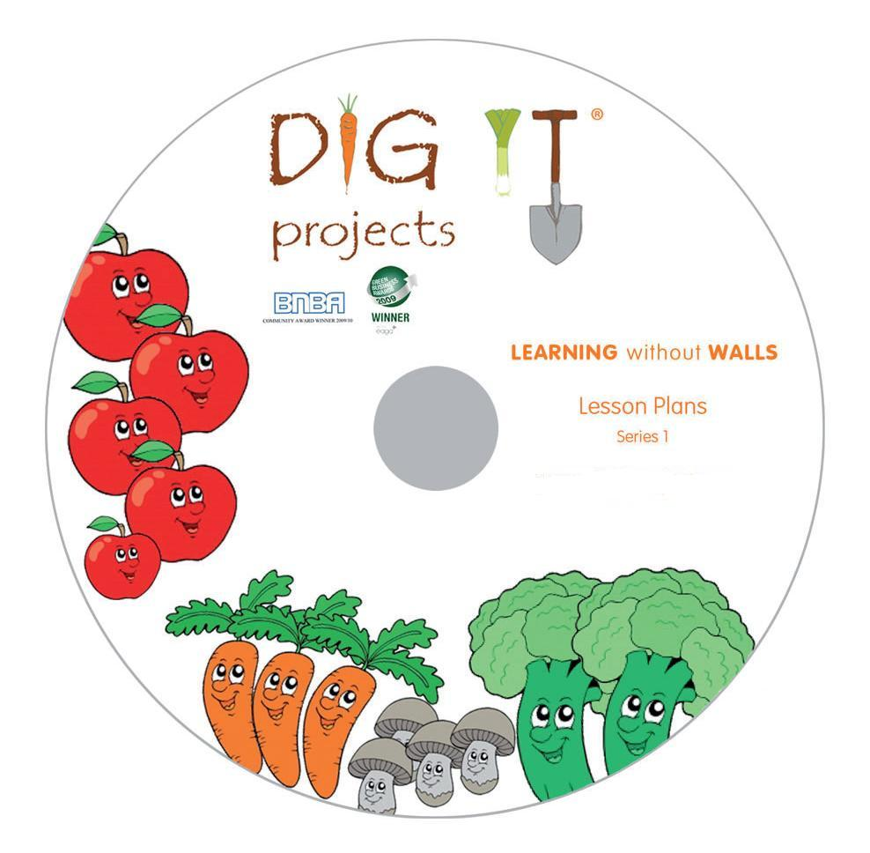

These are our new LESSON PLANS titled “LEARNING without WALLS” – Series 1, for teachers and learners to follow.
They have been developed by an approved UK OFSTED inspector and have also been looked at by a number of Head Teachers with excellent feedback. They are designed and formatted for Schools to follow, linking in with many current curriculum targets and subjects, based around "Growing" - Fruit, Vegetables, Herbs & Plants.

They can be used for All Primary Key Stages 1 and 2, as well as Secondary Education Key stage 3 and 4, year after year.

They are in Microsoft 2003 and 2007 format with a power point presentation along with the lesson plans to guide and follow you through the subject matter. They can be adapted and personalised to suit your requirements, enabling you to customise them.

There are 9 subjects with 9 presentations. These are divided into 17 Lesson Plans as below.

Also contained on the disc is extra "Support Material" relating to growing Herbs, and "Useful Web Links"
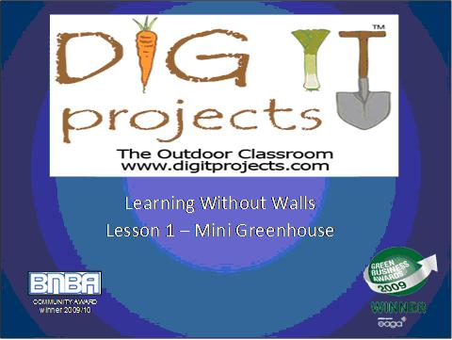
- Mini Greenhouse
- Compost
- Roots & Shoots
- Soil v Hydroponics
- Germination
- Photosynthesis
- Speed of Decomposition (Compost)
- Extracting Starch
- Herb Garden covers lessons 9-17
Please view our website at www.digitprojects.com for more innovative products and ideas.


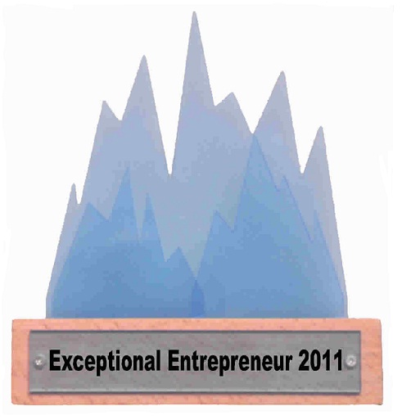



Community Award 2009

www.digitprojects.com
Copyright 2018 – Richard Smith / Dig It Projects Ltd – All Rights Reserved.

